Assignment 5

**DSA Spring 2024**

# Question No. 1: Graphs

Given an undirected [Graph](https://www.geeksforgeeks.org/graph-and-its-representations/) of **N** vertices, 1 to **N** and **M** edges in the form of a 2D [array.](https://www.geeksforgeeks.org/introduction-to-arrays/) The array **Arr [][],** where every row consists of two numbers **X** and **Y** which denotes that there is an edge between **X** and **Y**.

**Input:** N = 8, M = 7, Arr [] [] = {{1, 2}, {2, 3}, {4, 5}, {1, 5}, {6, 1}, {7, 4}, {3, 8}}

Your output will be:

|  |  |  |  |  |  |  |
| --- | --- | --- | --- | --- | --- | --- |
| 0 | 1 | 0 | 0 | 1 | 1 | 0 |
| 1 | 0 | 1 | 0 | 0 | 0 | 0 |
| 0 | 1 | 0 | 0 | 0 | 0 | 0 |
| 0 | 0 | 0 | 0 | 1 | 0 | 1 |
| 1 | 0 | 0 | 1 | 0 | 0 | 0 |
| 1 | 0 | 0 | 0 | 0 | 0 | 0 |
| 0 | 0 | 0 | 1 | 0 | 0 | 0 |
| 0 | 0 | 1 | 0 | 0 | 0 | 0 |

Considering the above information, perform the following tasks:

* 1. Write a program to create [an Adjacency Matrix of the given Graph.](https://www.geeksforgeeks.org/convert-adjacency-matrix-to-adjacency-list-representation-of-graph/)
  2. Write a program to create the Adjacency List of the above matrix.

# Question No. 2: Graphs

Consider the following graph and write a program that finds the adjacency matrix of the given graph. Show the adjacency matrix of the graph as well as the number of vertices that share the common edges.

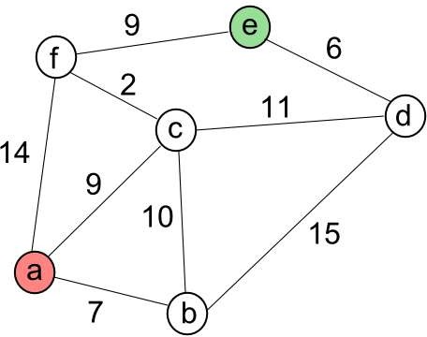

# Question No. 3: Graphs: BFS and DFS

Consider a graph given as below and find the paths from A to G with both strategies BFS and DFS. Also write a code to find these paths with both strategies.

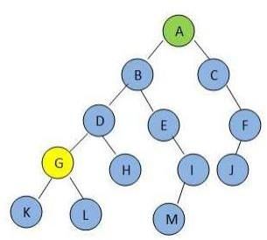

# Question No. 4

Implement a probing hash table and insert 10,000 randomly generated integers into the table and count the average number of probes used. This average number of probes used is the average cost of a successful search. Repeat this test 10 times and calculate minimum, maximum and average values of average cost. Run the test for both linear and quadratic  
probing and do it for final load factors 𝜆 = 0.1, 0.3, 0.5, 0.7, 0.9. Always choose the capacity of the table so that no rehashing is needed. For instance, for final load factor 𝜆 = 0.5, in order to insert 10,000 integers into the hash table, the size of the table should be approximately 20,000 (i.e., 10000⁄𝜆 = 10000⁄0.5 = 20000). You must make some adjustments to make table size a prime number. For instance, 20,011 is the prime number that is slightly larger than 20,000. You can refer to the following link for the list of prime numbers:  
<http://compoasso.free.fr/primelistweb/page/prime/liste_online_en.php>

At the end of your simulations, please fill in the following table.

